
JSE AGRICULTURAL PRODUCTS DIVISION

NUMBER: A597

DATE: 20 July 2005

SPECIAL GAZETTE

NUMBER:

DATE

JSE Limited
Reg. No. 2005/022939/06

ELECTRONIC SILO CERTIFICATES ACCEPTED AS A SYMBOL OF DELIVERY ONTO SAFEX

The process of accepting electronic silo receipts as operated by Silocerts (Pty) Ltd (hereafter referred to as ESC) as a means of delivery onto the exchange is currently being finalised. The JSE is in a position to sign an agreement with ESC (subject to a few minor changes), this after the agricultural clearing members negotiated their own Clearing Member Participant Agreement. The JSE Executive agreed to make use of ESC on the 11 July 2005.

The JSE is busy with a process of system development and integration to ensure electronic delivery is managed efficiently by the current JSE systems.

The JSE, by accepting the electronic silo receipt as a symbol of delivery, in no way guarantees or endorses Silocerts (Pty) Ltd as a service provider or any of its processes. The agreement between the two parties simply indicates the willingness by the JSE to, in addition to accepting paper receipts, also accept electronic versions thereof, all issued by an authorised silo owner. The JSE does not extend any additional guarantees to the market than those that already exist.

Each member and client interested in participating in this process is required to sign a Participant Agreement with ESC. For more information about the registration process and relevant costs associated with cash market transactions visit their web page www.silocerts.co.za

The JSE has negotiated that there be no ESC costs to participating clients when electronic silo receipts are delivered onto the exchange or received from the exchange. ESC costs will apply for any onward transfer of the electronic receipt in the cash/physical market.

To ensure no discrimination to any long position holders taking delivery, if the clients are not registered with ESC as a participant or have not indicated the relevant Safex participating client codes, the electronic receipt will be converted to paper and the usual delivery process will follow. For any short position holder to tender electronic silo receipts they would have to indicate which Safex client code is applicable.

There will be no changes to the allocations algorithm with both paper and electronic receipts treated in the same fashion.

Whilst the JSE is busy with the necessary changes to the contract specifications and systems, please will members indicate to the JSE who have already signed the ESC participant agreement and are willing to make and receive deliveries electronically. The JSE will require the same information from their clients who make use of the existing physical delivery process. This information is extremely important to ensure the success of the project going forward and can be emailed as soon as possible to chriss@jse.co.za . It is imperative for the JSE to have this information to determine the extent of envisaged use of electronic silo receipts.

More details on the implementation date will be distributed in due course. Should you have any further questions please do not hesitate to contact myself or Chris Sturgess on 011 520 7299.

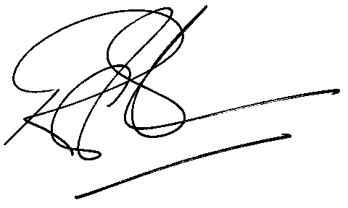

Rod Gravelet-Blondin
GENERAL MANAGER: AGRICULTURAL MARKETS DIVISION
Distributed by the Company Secretariat +27 11 520-7478

