
JSE AGRICULTURAL PRODUCTS MARKET

NUMBER: A633

DATE: 15 November 2005

SPECIAL GAZETTE

NUMBER:

DATE

JSE Limited
Reg. No. 2005/022939/06

CLARIFICATION ON VWAP MARK-TO-MARKET PROCEDURE

In future should a specific expiry qualify as a liquid contract in the last 30 minutes of trade, however the market be bid limit up or offered limit down in the last 15 minutes with limited or no trade taking place, the VWAP will be ignored and the contract will be mtm at the limit.

In the same way should the VWAP result in a mtm outside the daily price limits due to spread trades, the VWAP will be ignored and the expiry will be mtm at the price limit.

The above will be implemented with immediate effect. Please direct any questions to the Agricultural Products Division.

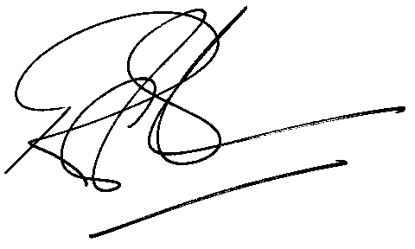

Rod Gravelet-Blondin
GENERAL MANAGER: AGRICULTURAL MARKETS DIVISION

Distributed by the Company Secretariat +27 11 520-7478

