
JSE AGRICULTURAL PRODUCTS DIVISION

NUMBER: A644

DATE: 3 January 2006

SPECIAL GAZETTE

NUMBER:

DATE

JSE Limited
Reg. No. 2005/022939/06

INTRODUCTION OF THE DEC 06 EXPIRY

The Dec06 contract will be introduced for WMAZ, YMAZ, SUNS and SOYA and will trade with out any standardised storage rates or location differentials where applicable.

These standardised rates should be released in the next few weeks.

The expiry months will be introduced for trading on Thursday 5 January 2006.

As we are in the process of considering possible minor changes to the wheat contract, the Dec06 expiry for WEAT will not be introduced at this stage. More about the possible proposed changes will be distributed shortly. The exchange will aim to have the contract listed by the end on January 2006.

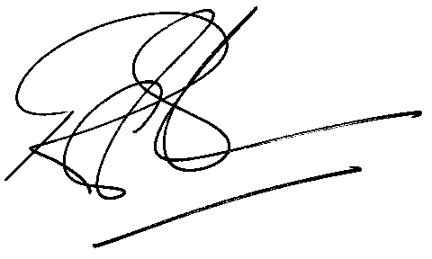

Rod Gravelet-Blondin
SENIOR GENERAL MANAGER: AGRICULTURAL PRODUCTS DIVISION

Distributed by the Company Secretariat +27 11 520-7478

