JSE AGRICULTURAL PRODUCTS MARKET NOTICE
Number A671
Date 17 March 2006

Introduction of further far out expiries

Following a request by the market place the exchange will introduce a number of far out trading months after the expiration of the Mar06 contract on the 22 March.

The Mar07, May07 and Jul07 expiry months for WMAZ, YMAZ and WEAT will all be introduced for trading on Friday 24 March 2006. Where applicable the contract will trade without any standardized differentials, storage rates, origin or grade discounts. These will only be finalized closer to the specific marketing season.

The SUNS contract main hedging months may change following discussions at an Advisory meeting and therefore the applicable expiries will be introduced later.

Possible changes also exist for the SOYA contract following proposed meetings with industry and therefore these expiries will also be introduced at a later stage.

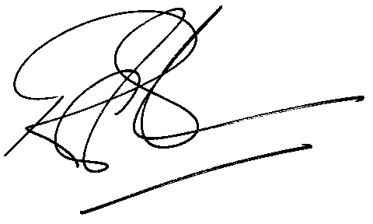

Rod Gravelet-Blondin
Senior General Manager
Agricultural Products Division
Tel :+27 11 520-7258
Fax :+27 11 520-7551
RodGB@jse.co.za

Distributed by the Company Secretariat +27 11 520 7478

