JSE AGRICULTURAL PRODUCTS MARKET NOTICE

Number A716

Date 2 October 2006

Proposed SOYA delivery points for the 2007 marketing season

As indicated by notice A693, the exchange has agreed with industry participants to increase the number of delivery points and at the same time accepts silos that only have road access.

After receiving a number of requests from industry for additional delivery points and consulting with the various silo operators, the following list of silos is proposed for the next marketing season:
Current list of silos |  |  | Proposed additional silos
Afrikaskop | OTK |  | Endicott | OTK
Ascent | VRY |  | Ermelo | OTK
Bergville | OTK |  | Ficksburg | OVK
Bethal | OTK |  | Harvard | OTK
Bethlehem | OTK |  | Nigel | OTK
Bloekomspruit | OTK |  | Paulpietersburg | OTK
Bloedrivier | OTK |  | Standerton | OTK
Brits | MGK |  | Tweeling | VRY
Bronkhorstspruit | OTK |  | Dryden | OTK
Carolina | OTK |  | Greylingstad | OTK
Danielsrus | VRY |  | Val | OTK
Dannhauser | OTK |  | Vryheid | OTK
Davel | OTK
Devon | OTK
Driefontein | OTK
Eloff | OTK
Estancia | OTK
Frankfort | VRY
Harrismith | OTK
Holmdene | OTK
Kendal | OTK
Leslie | OTK
Lothair | OTK
Lydenburg | OTK
Mkondo | TWK
Middelburg | OTK
Northam | MGK
Overvaal | OTK
Panbult | TWK
Pan | OTK
Potgietersrus | NTK
Platrand | OTK
Reitz | VRY
Stoffberg | OTK
Trichardt | OTK
Villiers | VRY
Vrede | VRY
Warden | VRY
Winterton | OTK
Wonderfontein | OTK

All fifty-two proposed delivery points will trade at the same basis price – zero differentials.

Please will members consult with their relevant clients and confirm that the proposed list is acceptable. All comments can be forwarded to chriss@jse.co.za and are required before the 13 October 2006; the final list of registered silos for 2007 will be distributed shortly thereafter.

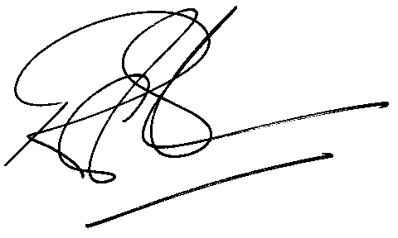
Rod Gravelet-Blondin
Senior General Manager
Agricultural Products Divisions
Tel :+27 11 520-7258
Fax :+27 11 520-7551
RodGB@jse.co.za

Distributed by the Company Secretariat +27 11 520 7478

