JSE AGRICULTURAL PRODUCTS MARKET NOTICE

Number A752
Date 6 February 2007

Confirmation of the WOPT contracts trading period and acceptable grade for delivery.

Members and clients are reminded that the white maize grade two (WOPT) contract, introduced for trading in July 2006 will only continue trading until the end of the March 2007 expiry month as per notice A702 distributed in August last year.

Only grade WM2 white maize may be delivered onto the contact in completion of a futures contract as per the contract specifications and confirmed by notice A692, no WM1 maize will be accepted for delivery on the WOPT contract.

The reintroduction of the contract will depend on the type of grades harvested in the new season.

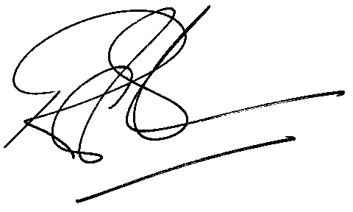

Rod Gravelet-Blondin
Senior General Manager
Agricultural Products Division
Tel :+27 11 520-7258
Fax :+27 11 520-7551
RodGB@jse.co.za

Distributed by the Company Secretariat +27 11 520 7478

