JSE AGRICULTURAL PRODUCTS MARKET NOTICE

Number A799
Date 7 June 2007

JSE Agricultural Products Division discount on specific “ring fenced” transactions.

The JSE APD has decided to allow a trading fee discount to members and clients who wish to move positions into a nominated account to ensure they can be clearly identified and separated from other activities for a specified period of time and then at a later stage transfer them back to the original traded account.

The exchange has agreed to accommodate such specific requests provided that the below specified conditions are complied with and that the information requested by the JSE is provided by the member concerned prior to the transaction.

Conditions:

- members are required to declare upfront the two trading accounts to be used and the total number of contracts to be moved,
- the JSE must be provided with the required information by the latest 10h00 for the transaction to be processed on the same day
- once the position exists they will be moved via a report only trade, facilitated by the exchange. NO NEW POSITIONS will ever be created
- positions will be moved at market related price levels
- a notice will be distributed via the trading system informing the market that a ring fenced (RF) trade has been processed
- the report only trade in essence moves the identified position from one entity to another predefined entity code
- when the instruction is received from the member to return the positions to the account holder, the exchange using the report only functionality will move the RF positions back to the original account holder
- the market will again be notified of this via the trading engine

The Agricultural Products Division should be provided with the following information for the facilitation of “ring fenced” business:
- the relevant account numbers
- the number of contracts
- the market related price level

The above process will be facilitated at the JSE’s discretion and will be reviewed again in the next 12 months.

With regards the trading fee discount, the second report only trade facilitated by the JSE will be processed at no JSE cost, clearing and trading members may decide to levy a fee for the transaction.

To further highlight the trading discount through an example:
Member ABC decides to ring fence a position of short 50 contracts by requesting the JSE to move the position to client code XYZ99. This will be processed at normal JSE fees for both legs of the transaction,
ABC buying 50 contracts JSE fee 12c/ton
XYZ99 selling 50 contracts JSE fee 12c/ton
Three months later the member requests the position to be transferred back to ABC, the resulting report only trade will be processed:
XYZ99 buys 50 contracts JSE fee 0c/ton
ABC sells 50 contracts JSE fee 0c/ton

Should any other variation of the above be requested, the transaction will have to be executed on screen and normal JSE trading fees will apply.

Members interested in making use of the transaction type and qualifying for the subsequent discount can contact Chris Sturgess (011 5207299) or Graham Voller (011 5207176).

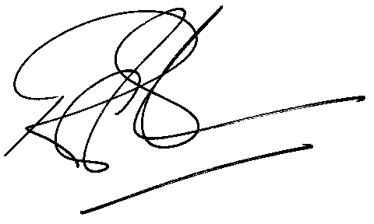

Rod Gravelet-Blondin
Senior General Manager
Agricultural Products Division
Tel :+27 11 520-7258
Fax :+27 11 520-7551
RodGB@jse.co.za

