JSE AGRICULTURAL PRODUCTS MARKET NOTICE

Number AXXX
Date 8 Feb 2008

Introduction of the March and May 2009 expiry.

Please note the March and May 2009 expiry month for SUNS and SOYA contracts will be introduced for trading on Wednesday 13 Feb 2008

Where applicable the storage rates, location differentials, grade discounts and origin discounts for the various products have not being finalized and will only be available at a later stage.

Participants are again reminded that the JSE trades the underlying grades of products as published by the National Department of Agriculture in South Africa, should any changes be made to these at any time they will applied to the applicable derivative contract(s).

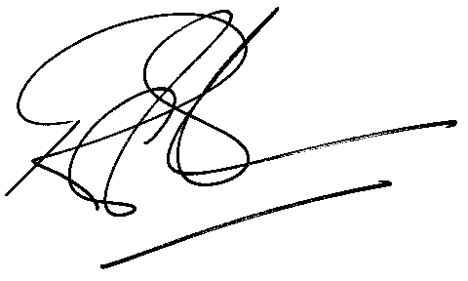

Rod Gravelet-Blondin
Senior General Manager
Agricultural Products Division
Tel :+27 11 520-7258
Fax :+27 11 520-7551
RodGB@jse.co.za

