JSE AGRICULTURAL PRODUCTS MARKET NOTICE

Number A943

Date 26 August 2008

REQUEST FOR COMMENTS REGARDING THE CONTINUED USE OF LOCATION DIFFERENTIALS

It was agreed at the meeting of the Agricultural Products Division Advisory Committee held on 21 August that all participating members and their constituents should be invited to submit, in writing, comments regarding the use of location differentials as presently operated by the JSE Agricultural Products Division for delivery in completion of a futures contract. All submissions should be received by the JSE by close of business on Tuesday 30 September.

The submissions would form the basis for a workshop to be arranged by the JSE to discuss the ongoing use of location differentials if it is apparent from the submissions that no way forward is clearly identified. Following the receipt of the written submissions and, if necessary, the discussion at the workshop, the JSE will take a decision regarding the ongoing use of the system of location differentials. This decision would then be applicable for an agreed number of marketing seasons going forward.

Participants are encouraged to succinctly and clearly indicate their views on the following issues:

The ongoing use of location differentials (yes/no), with a detailed motivation based on reasons for the choice made
The possibility of doing away with location differentials on the wheat contracts as from the Dec09 contract before removing location differentials from all the other remaining products.
Preliminary dates for the possible workshop will be communicated shortly.
Should there be any specific questions regarding the request please do not hesitate to contact myself or Chris Sturgess (+27 11 5207299)
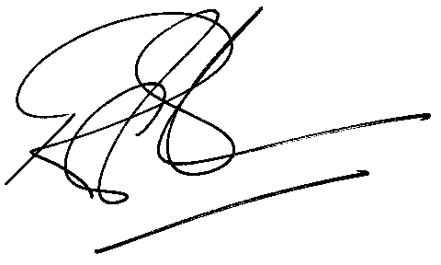

Rod Gravelet-Blondin
Senior General Manager
Agricultural Products Division
Tel :+27 11 520-7258
Fax :+27 11 520-7558
RodGB@jse.co.za

Distributed by the Company Secretariat +27 11 520 7478

