JSE AGRICULTURAL PRODUCTS MARKET NOTICE

Number A996A

Date 2 December 2008

CONTRAVENTION OF SECTION 75 OF THE SECURITIES SERVICES ACT, No. 36 OF 2004
Members are referred to a media release by the Directorate of Market Abuse detailing a contravention of Section 75 of the Act which took place in Agricultural Derivatives, specifically in the sunflower seeds contract. For ease of reference, an extract of the media release is inserted below and the full release is also attached:
“DMA vs Van Zyl
The Enforcement Committee considered an allegation of a contravention of section 75 of the Act (price manipulation) against Mr J A van Zyl as a result of his trading in Sunflower futures contracts, a security trading on the South African Futures Exchange, a division of the JSE Limited. Mr Van Zyl admitted that he contravened section 75 of the Act by executing transactions on the market that resulted in no change in the beneficial ownership of the securities. The Enforcement Committee inter alia took into account that his transactions resulted in a substantial loss in his personal capacity, that he admitted the contravention, and expressed his regret for his activities. It imposed an administrative penalty of R50 000.”
Mr Albertus Johannes van Zyl acted in a client capacity when the above transactions took place.
Members are again reminded that executing transactions on the central order book which result in no change in beneficial ownership is a contravention of the Securities Services Act and all the necessary preventative measures must be taken by members to ensure that this does not occur.

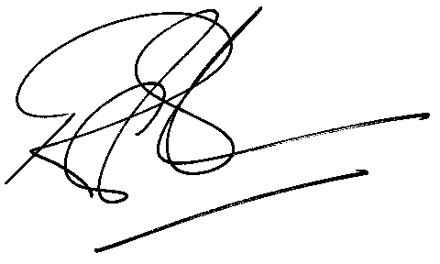

Rod Gravelet-Blondin
Senior General Manager
Agricultural Products Division
Tel :+27 11 520-7258
Fax :+27 11 520-7558
RodGB@jse.co.za

Distributed by the Company Secretariat +27 11 520 7346

