JSE AGRICULTURAL PRODUCTS MARKET NOTICE

Number A1004

Date 2 January 2009

Clarification of the APD Open Order Period

This serves as a reference document to assist all users who have queried the new Open Order Period functionality, which is currently operational between 8h50 and 8h58 local time.

Originally intended to assist those dealers who service a multitude of clients and who found it difficult to load multiple orders at the start of the market, the exchange provided an order period where orders could be entered at any level and that would only appear on the active orders view of the specific member firm. The rest of the market would therefore not be able to view any of the orders loaded during this open order period. The exchange at all times has full access to all orders entered and can view all activity performed by the dealers. The orders entered during this period may be suspended and/or deleted provided this is done before the period closes, currently set to one minute before market open. Once the period closes, no further orders can be added as well as any existing orders be suspended or resubmitted.

It is also important to note that on days when there is a possible price limit move, either up or down, those orders entered at the start of the open order period will be loaded onto the top of the order stack as the market moves out of the open order period. These orders are sorted based on order entry time.

With the open order period currently set to close at 8h59, the system then rebuilds the order stack in the same fashion as it would during the continuous trading period to ensure the best bids and offers are on top. Should there be multiple orders at the same price, these are then sorted based on the time the order was entered. So orders entered first will be loaded above those entered later on during the order period. This rebuilding of the order stack is processed by the exchange and any orders that cannot be matched based on price will be published to the market ready for trading at the market open, which is currently 9h00.

Since spread and split orders can result in the loading of possible phantom (implied) orders in the underlying futures screen, the open order period is designed in such a fashion that all naked orders (those orders which are the result of a direct future bid or offer) will match first, only then will possible spread combinations be generated, if there are any phantoms that could result in a spread matching then these will be traded and finally any split combinations are processed for any possible matches.

To further expand on the detail around building of the order stack consider the following example:
- 8:50.00 Buy 3 March WMAZ @ 1813
- 8:50.00 Sell 10 March WMAZ @ 1815
- 8:52.00 Buy 2 March WMAZ @ 1803
- 8:52.01 Buy 3 March WMAZ @ 1803
- 8:54.00 Sell 50 March WMAZ @ 1850
- 8:55.00 Sell 2 March WMAZ @ 1807
- 8:56.30 Buy 1 March WMAZ @ 1806
- 8:58.01 Sell 6 March WMAZ @ 1808

The bid/offer box would therefore look like this at 8h59:00 when rebuilding of the stack occurs:

Time | Qty | Bid | Offer | Qty | Time
8H50:00 | 3 | 1813 | 1807 | 2 | 8H55:00
8H56:30 | 1 | 1806 | 1808 | 6 | 8H58:01
8H52:00 | 2 | 1803 | 1815 | 10 | 8H50:00
8H52:01 | 3 | 1803 | 1850 | 50 | 8H54:00

After rebuilding the stack the only trade than could be matched will be the bid at 1813, since this bid was loaded before the offer, the bid price is referenced for matching purposes even though the offer was lower. The offer for 6 contracts at 1808 would trade with the remaining 1 contract at 1813, again because this offer was loaded after the bid order. The opposite would apply if the offer was loaded before the bid.

The bid/offer box would update as follows for the 9h00 market open:
 | Qty | Bid | Offer | Qty | Time | High | Low | Volume
 | 1 | 1806 | 1808 | 5 | 8h59 | 1813 | 1813 | 3
With depth as follows
 | 2 | 1803 | 1815 | 10
 | 3 | 1803 | 1850 | 50

The high and low in the stats columns are updated accordingly using the same business rules as during the continuous trading session, any spread or split orders matched directly in their respective windows will not update the high or low values but will be reflected under volumes traded.

Should you have any further questions regarding the open order period please contact the Agricultural Products Division on 011 520 7535 or commodities@jse.co.za
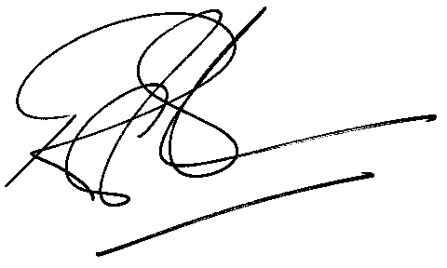

Rod Gravelet-Blondin
Senior General Manager
Agricultural Products Division
Tel :+27 11 520-7258
Fax :+27 11 520-7558
RodGB@jse.co.za

Distributed by the Company Secretariat +27 11 520 7591

