JSE AGRICULTURAL PRODUCTS MARKET NOTICE

Number A1012A

Date 27 January 2009

Introduction of Foreign Commodity Derivatives

The JSE Agricultural Products Division is delighted to announce the first product to list under the foreign commodity derivatives initiative. After signing a licensing agreement with the CME Group, the largest and most diverse derivatives exchange in the world, the JSE is able to list a CORN futures contract that will be cash settled off the CBOT contract. Options on the futures contract will be introduced in due course.

Rule and Compliance obligations
The necessary amendments to the derivative rules and directives have been implemented and can be reviewed via notice A1006A and A1006B.

The compliance obligations applicable to members in relation to trading, hedging and holding positions in foreign commodity derivatives are specified in the directives and are in terms of Section H of the Exchange Control Rulings.

Contract Specifications
The detailed contract specification for the CORN contract is attached with more information available on the web site: http://www.safex.co.za/ap/

Expiries introduced
The introduction of the May09, Jul09 and Sep09 CORN expiries will be introduced on Wednesday 28 January 2009 with Rand Merchant Bank and ABSA Bank as the approved market makers. Standard Bank of South Africa will also participate as market maker once they have the necessary SARB approval and systems in place.

Market Makers
In order to comply with Reserve Bank approval, until such time as the new products are able to trade anonymously (no member codes appearing in the depth window), the JSE has assigned a unique market maker member code for the local participants so that they can distinguish quoting amongst themselves. In this regard please note the following codes will be in use:
ABSA Bank will appear as ABSA
Rand Merchant Bank will appear as RAND
Standard Bank will appear as STDS

Report Only transactions
Due to the limited three hour trading session, the JSE will accommodate report only trades resulting from over the counter transactions which are completed outside the usual trading hours. These transactions will be subject to the following:
- Notification of the trades must reach the JSE no later than 7h30 the following morning
- Members representing the buyers and sellers must confirm the transaction via email, including all relevant details, to the JSE. The email address to use is commodities@jse.co.za
- A minimum number of 50 contracts will be processed per transaction
- The price at which the transaction will be accommodated must fall within the trading range of the international markets whilst the local market was closed (considering the currency component as well as the underlying foreign market)

No other report only trade activity will be considered during trading hours other than the already established reported trade types, namely EFP’s, EFR’s, RF trades and net offs between accounts of the same legal entity.

Loading the new instrument onto Nutron
The new expiries specific to the CORN contract can be download onto the NUTRON trading front end by right clicking on the main futures window and selecting “add/delete contracts” and then select add/delete Class of contract.


Thereafter highlight the CORN contract from the drop down list and select the add sign:

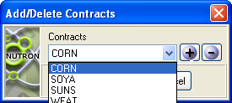

After selecting the “add” and “OK” buttons the new expiries will appear in the main futures trading window. Both calendar spreads and splits (cross commodity spreads) will be available for trading. Note when trading the WMAZ/CORN and YMAZ/CORN splits, should you buy the split this will simultaneously result in a buy on the CORN leg and a sell on either the WMAZ or YMAZ leg respectively. The opposite applies to selling the split. The expiries will be available for downloading on Tuesday afternoon 27 January 2009.

For any detailed questions regarding the specifications please contact Chris Sturgess on 011 5207299 or email the division on commodities@jse.co.za

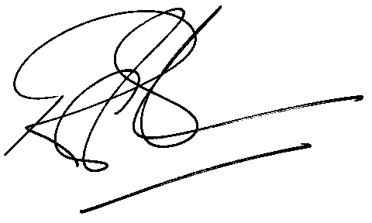
Rod Gravelet-Blondin
Senior General Manager
Agricultural Products Division
Tel :+27 11 520-7258
Fax :+27 11 520-7558
RodGB@jse.co.za

Distributed by the Company Secretariat +27 11 520 7591

