JSE AGRICULTURAL PRODUCTS MARKET NOTICE

Number A1015

Date 27 January 2009

Safex silo receipts reported lost

Please will members and clients note that the following Kaap Agri Bpk (silo owner code KAA) Safex silo receipts have been reported lost and therefore are canceled with immediate effect.

Range including both numbers is133300 to 133499

To further assist the market, the exchange will record on its webpage a list of all Safex silo receipts reported lost by the various silo operators. The exchange does not guarantee the accuracy of the webpage since silo operators will be responsible for supplying us with the information first.

The information can be viewed via the following shortcut:

http://www.safex.co.za/ap/docs/receipts_lost/Safex%20Silo%20receipts%20reported%20lost.pdf

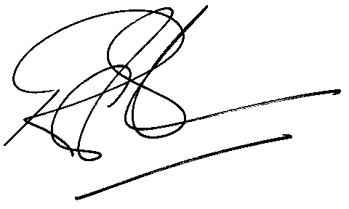

Rod Gravelet-Blondin
Senior General Manager
Agricultural Products Division
Tel :+27 11 520-7258
Fax :+27 11 520-7551
RodGB@jse.co.za

Distributed by the Company Secretariat +27 11 520 7591

