JSE AGRICULTURAL PRODUCTS MARKET NOTICE

Number A1021
Date 18 February 2009

Options closeout procedure will recognise sub account positions

After the last options closeout, we had numerous requests to recognize option closeout down to a sub account level. Please note this request has been accommodated with the necessary software upgrade to our own internal clearing solution. On the afternoon of the next option closeout (23 February), Nutron will now reflect in “Con Positions” the resulting futures positions down to a sub account level, although the net positions will still be available in the “Members Consolidated Positions” view. All the necessary download files will also be available acknowledging the position down to a sub account level. Members are reminded that Clearing Members run a close out procedure in parallel to the JSE and so they should double check their Nutron positions on a sub account basis with those on the Clearing Members statements.

To help illustrate the improvement where options close out positions will be reflected down to a dealer and sub account level, please consider the below example:

Positions before closeout:

Contract | Sub Account | Dealer | Open | Buy | Sell | Close
DEC 08 WMAZ | ABC11 | TOM | 10 | 0 | 0 | 10
DEC 08 WMAZ 100 C | ABC11 | DDG | 10 | 0 | 0 | 10
DEC 08 WMAZ 6000 P |  | TOM | 10 | 0 | 0 | 10
DEC 08 WMAZ 200 C | ABC12 | DDG | 10 | 0 | 0 | 10
DEC 08 WMAZ 300 C | ABC12 | TOM | 10 | 0 | 0 | 10

Positions down to a dealer level after closeout assuming the MTM was R2000.

Contract | Sub Account | Dealer | Open | Buy | Sell | Close | Exercised/  Abandoned
DEC 08 WMAZ | ABC11 | TOM | 10 | 0 | 0 | 10 | Future
DEC 08 WMAZ | ABC11 | DDG | 0 | 10 | 0 | 10 | Future
DEC 08 WMAZ |  | TOM | 0 | 0 | 10 | -10 | Future
DEC 08 WMAZ | ABC12 | DDG | 0 | 10 | 0 | 10 | Future
DEC 08 WMAZ | ABC12 | TOM | 0 | 10 | 10 | 10 | Future
DEC 08 WMAZ 100 C | ABC11 | DDG | 10 | 0 | 10 | 0 | Exercised
DEC 08 WMAZ 6000 P |  | TOM | 10 | 0 | 10 | 0 | Exercised
DEC 08 WMAZ 200 C | ABC12 | DDG | 10 | 0 | 10 | 0 | Exercised
DEC 08 WMAZ 300 C | ABC12 | TOM | 10 | 0 | 10 | 0 | Exercised

“Con Positions” view provides a net position per sub account:

Contract | Sub Account | Open | Buy | Sell | Close
DEC 08 WMAZ | ABC11 | 10 | 10 | 0 | 20
DEC 08 WMAZ |  | 0 | 0 | 10 | -10
DEC 08 WMAZ | ABC12 | 0 | 20 | 0 | 20

“Members Consolidated Positions” view providing a true net position member firm:

Contract | Open | Buy | Sell | Close
DEC 08 WMAZ | 10 | 30 | 10 | 30

For any further questions please contact the Division or more specifically Graham Voller on +27 11 5207176

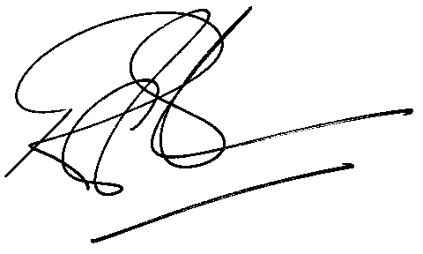

Rod Gravelet-Blondin
Senior General Manager
Agricultural Products Division
Tel :+27 11 520-7258
Fax :+27 11 520-7558
RodGB@jse.co.za

