JSE AGRICULTURAL PRODUCTS MARKET NOTICE

Number A1023
Date 20 February 2009
Introduction of the Dec 2009 expiry for wheat.
Please note the Dec 2009 expiry for the WEAT contract will be introduced for trading on Tuesday 24th February 2009.

The Dec09 wheat contract be introduced with the same contract specifications as before, therefore the use of location differentials, grade discounts for B2 and B3, origin discounts and Randfontein as the basis point will continue as before for the next marketing season commencing 1 October 2009. These matters were discussed at the meeting of the Agricultural Products Advisory Committee.

The same origin discounts will apply as per the previous year, namely:

- Wheat from the following origins acceptable for delivery at a ZERO origin discount:
USA Hard Red Spring (Dark Northern Spring and Northern Spring wheat), No 3 or better Canadian Red Western Spring wheat, Australian Hard, Australian Prime Hard, Australian Prime White and Australian Standard White wheat

- Wheat from the following origins acceptable for delivery at a R100 per ton discount:
Argentina, USA Hard Red Winter wheat and German Type A or B wheat

The JSE will determine the grade discounts going forward for B2 and B3 applying the same methodology as currently in use between Grain South Africa and National Chamber of Milling. The applicable discounts for the 2009/10 marketing season will be released by the end of August 2009 in line with the other rates.

The Dec09 expiry will be introduced with the storage rate, grade discounts and location differentials not finalized. These rates will be finalized closer to the new marketing season and will be released by the last business day in August 2009.

Participants are again reminded that the JSE trades the underlying grades of products as published by the National Department of Agriculture in South Africa, should any changes be made to these at any time they will applied to the applicable derivative contract(s).

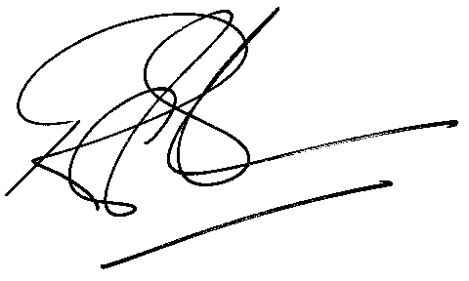

Rod Gravelet-Blondin
Senior General Manager
Agricultural Products Division
Tel :+27 11 520-7258
Fax :+27 11 520-7551
RodGB@jse.co.za

