JSE AGRICULTURAL PRODUCTS MARKET NOTICE

Number A1025
Date 23-Feb-2009

Introduction of the April Soya 2009 expiry

Similar to note A1022, the soya market will also be accommodated with the April expiry to be available for trade sooner, it in future will be introduced 40 business days preceding the actual month, in this way giving the market an additional 20 days to trade the contract.

Since we have already missed this date for the Apr09 expiry, it will be introduced with the Dec09 WEAT expiry on Tuesday the 24th February 2009.

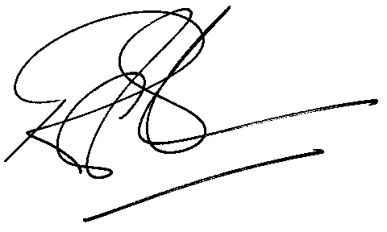

Rod Gravelet-Blondin
Senior General Manager
Agricultural Products Division
Tel :+27 11 520-7258
Fax :+27 11 520-7551
RodGB@jse.co.za

