JSE AGRICULTURAL PRODUCTS MARKET NOTICE

Number A1032A

Date 12 March 2009

Location differentials for White and Yellow Maize 2009/10 marketing season

The location differentials for white and yellow maize have been finalized for the 2009/2010 marketing season and are attached in excel format.

As per previous year’s, a combination of road and rail rates were considered when adjusting the location differentials. The adjustment was then based on the silo owner’s average out loading, per rail and road service considering all registered delivery points. From the information supplied, which included members and transport companies, it was decided to increase the road component by 9% and the rail component by 14%. The final percentage increase therefore varied between 9% and 13,3% depending on the rail vs road component for each silo owner. The differentials of last year formed the basis to which the percentage increase was applied.

It was agreed at an APD Advisory Committee meeting that the rail requirement as per appendix D of the contract specifications be amended to allow for silos to remain registered if road only access existed. This decision was made after a number of delivery points were affected due to the inability of the rail service provider to maintain the operation of the rail line. The JSE will therefore in future accommodate silo applications which only have road access. The access criteria are still to be finalized however in essence the silo complex must be accessible via a good road network.

The following silos are only accessible via road:
Goeiehoek, Grootvlei, Leeuspruit, Bloekomspruit, Vrede

There is a possibility that the rail service to Vrede may be repaired soon, if this is completed before the start of the new season the differential will be adjusted accordingly. Should the rail service become available anytime after the start of the marketing season, the location differential will not be adjusted until the new season commences.

Please note the rail line to Ascent has been repaired and is operational again, the differential was therefore adjusted using a road and rail component.

NWK, owned and operated Hibernia silo, relies on the use of a private rail siding, please note that the final buyer moving product via rail will be billed an additional R5 per ton for this service. This costs is included in the published differential should the buyer make use of rail to out load the product.

Members and clients are again reminded that the published location differentials are indicative of transport costs for product from the registered silo to Randfontein, which is the basis for the standardized futures contract. It is impossible that this rate will be 100% accurate throughout the year as transport rate factors change. Throughout each marketing season the basis value at each silo, created through supply and demand, must always be considered before making physical delivery onto the exchange.

The standard storage rate for the marketing season 1 May 2009 – 30 April 2010 has been calculated based on the new methodology as agreed by the APD Advisory Committee. The January 2009 PPI for domestic output released on the 26th February 2009 was 9.2%. This rate, applied to the current storage rate, results in the maize standard storage rate increasing to 46 cents per ton per day applied to all Safex silo receipts delivered in completion of a futures contract.

Please ensure that when making delivery of silo receipts issued in the previous marketing season, all storage is paid up to and including 30 April 2009.

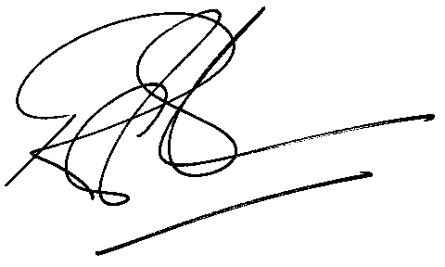

Rod Gravelet-Blondin
Senior General Manager
Agricultural Products Division
Tel :+27 11 520-7258
Fax :+27 11 520-7558
RodGB@jse.co.za

Distributed by the Company Secretariat +27 11 520 7591

