Market Notice
Number: | A1035
Date | 17 March 2009

Updating client records as displayed on the members trading front end

Since implementation of the new derivative’s software, members have the ability to enter new client registrations as well as update existing details using either the NUTRON trading system or their own API.

The updating of clients records is in accordance with the JSE Derivative Rules 7.60 and more particularly:

7.60.2.3 The JSE shall maintain a record of the clients which are registered as clients of
trading members and it shall keep a record of the particulars associated with
each client as required under rule 7.60.2.2.
7.60.2.3.1 A member shall ensure that the particulars relating to his
clients are correct and up to date at all times.
7.60.2.3.2 The member shall ensure that clients, which have ceased
trading with the member, are removed from the register as
being the clients of the member.

We encourage all compliance officers to ensure the data loaded per client is accurate in accordance with the above rules. Should members wish to deregister any clients and remove them from the member database on the trading front end, please email commodities@jse.co.za.

To assist users with any queries regarding the various data fields, please see a detailed description for the fields as found on the NUTRON front end. The detailed NUTRON user manual is available on the web page: http://www.safex.co.za/pub/Orion_Training_Material/ . To assist the exchange please ensure the clients name and surname is entered in the format as described in section A.4 and A.5 below.

Rod Gravelet-Blondin
Senior General Manager
Agricultural Products Division
Tel :+27 11 520-7258
Fax :+27 11 520-7558
RodGB@jse.co.za

Distributed by the Company Secretariat +27 11 520 7591

Section A. First view available to enter a client’s details

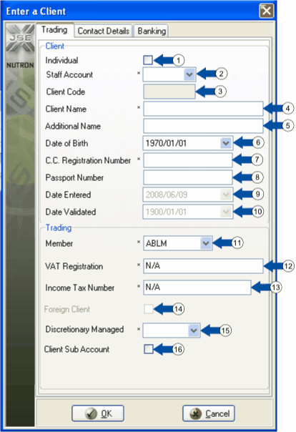

 | Mandatory fields on the Trading tab of the Enter a Client window are marked with an asterisk (*).

1. Check this check box to indicate that the new client is an individual. Leave the check box unchecked to indicate that the client is a company.
2. Use this dropdown list to indicate whether or not the client has a staff account by selecting either the YES or the NO list item within the dropdown list.

3. A code for the new client is generated by the system and cannot be entered by the user.

4. Under client name, INSERT THE CLIENTS SURNAME, up to 80 characters can be captured inside this text box.

5. Under additional client name, INSERT THE CLIENTS FULL NAMES, up to 52 characters inside this text box.

6. Enter the client's date of birth, only applicable to individuals.

7. Use this text box to enter the client's ID number if you checked the Individual check box described in numbered note 1. Enter the CC registration number for a company here if you left the Individual check box unchecked.

8. Optionally, enter the client's passport number inside this check box.

9. This control holds the date the new client record was loaded.

10. This control holds the date the new client record was validated.

11. Use this dropdown list to select the member organization to which the client belongs – this is system generated.

12. Enter the client's VAT Registration Number into this text box, this is crucial for all clients involved with physical deliveries of agricultural commodities.

13. Enter an income tax number of up to 52 characters into this text box.

14. All foreign clients will be loaded by the JSE to ensure all information is captured in line with Reserve Bank requirements.

15. Use this dropdown list to indicate whether or not the client’s account is discretionary managed by selecting either the YES or the NO list item within the dropdown list.

16. The client sub account functionality has been deactivated until further notice.

Section B.
Click the Contact Details tab to make it active so you can continue to provide details for the new client record.

Use the numbered controls within the Contact Details tab screen shot below to learn how to complete the second stage of creating a new client record.

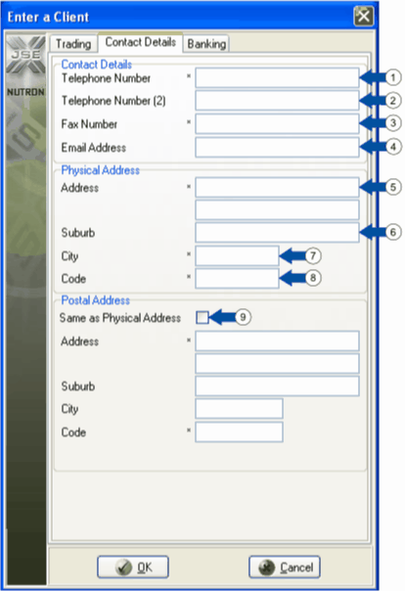

Mandatory fields on the Contact Details tab of the Enter a Client window are marked with an asterisk (*).

1. Enter your first choice of contact telephone number for the client into this text box. You can type in a telephone number of up to 24 characters.

2. Optionally, enter an alternative contact telephone number for the client into this text box. You can type in a telephone number of up to 24 characters.

3. Enter a contact fax number for the client of up to 24 characters inside this text box.

4. Enter a contact email address for the client of up to 52 characters inside this text box. The Nutron back end will check this email address for validity.

5. Enter client physical address details up to suburb level within these two text boxes. The first text box can accommodate up to 52 characters and the second text box can accommodate up to 30 characters.

6. Optionally, enter a suburb name of up to 43 characters as part of the client’s physical address details into this text box.

7. Enter a predetermined city code of 3 characters into this text box for the client’s city.

8. Enter a postal code of 4 characters into this text box for the client’s suburb/city.

9. Check this check box if the client has the same postal address as physical address. If this is not the case, leave the check box unchecked and enter client postal address details into the text boxes below the check box. Numbered notes 5. to 8. above advise you of the maximum or required number of characters for each text box.

Section C.
Click the Banking tab to make it active so you can continue to provide details for the new client record.

Use the numbered controls within the Banking Details tab screen shot below to learn how to complete the final stage of creating a new client record.

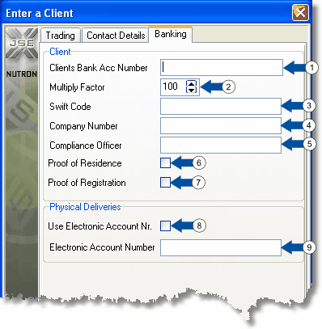

1. Optionally, enter a bank account number for the client of up to 18 characters into this text box.

2. Optionally, if the new client will pay more than 100% margin, enter values of 125, 150 or 175 into this spin box. THIS FUNCTIONALITY IS IN THE PROCESS OF BEING ENHANCED WHEREBY ONCE A CLEARING MEMBER HAS ENTERED A MARGIN REQUIREMENT, THE MEMBER FIRM WILL ONLY BE ABLE TO INCREASE THIS AND WILL NOT BE ABLE TO REDUCE THE REQUIREMENT

3. Optionally, enter a Swift code for the client of up to 52 characters into this text box. Swift (Society of Worldwide International Financial Transfers) provides a set of standards for electronically transferring financial data worldwide.

4. Optionally, enter a company number of up to 52 characters for the client into this text box.

5. Optionally, enter the name of the client’s compliance officer into this text box.

6. Optionally, check this check box if the client has provided you with proof of residence.

7. Optionally, check this check box if the client has provided you with proof of registration.

CRUCIAL TO AGRICULTURAL ELECTRONIC DELIVERIES

8. Check this check box if the new client has an ESC (Electronic Silo Certificate) account number, checks are underway to ensure the ESC account in use ties back to the ID number or company registration of the client

9. Enter an electronic account number of up to 29 characters for the client here if you checked the check box mentioned in numbered note 8. This will be validated by the ESC system.

Click the Enter a Client window button to display a window asking you if you want to load another client. Click the button of this window to close it while keeping the Enter a Client window open. You can then proceed to create an additional client record as described above. Click the button of this window to close both it and the Enter a Client window.

Section D: To update existing client details the following process should be followed, see section 3 and 5

A View [Member Code Dealer Code] APD Clients window has five functionality buttons. Separate numbered notes below discuss each of these buttons as they appear from left to right from the bottom left corner of the window.

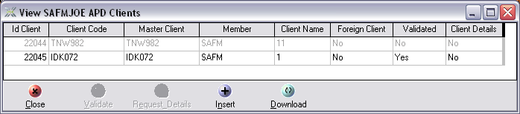

1. The  button closes the View [Member Code Dealer Code] APD Clients window.

2.  / 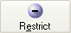 button functionality is only available to master dealers. A / button is disabled until you select the row of a client record you want to validate or restrict inside the data grid. The button appears as a button when you select the row of a client record that can be validated. The button appears as a button when you select the row of a client record that can be restricted. You select record rows within the data grid by double clicking each row you want to select. You also deselect record rows within the data grid by double clicking them.

3. The 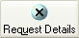 button is disabled until you select the row of a client record for which details are available within the data grid. You select record rows within the data grid by double clicking each row you want to select. You also deselect record rows within the data grid by double clicking them.

4. Click the  button to display an Enter a Client window as described under heading 12.2.1.3 that lets you add new client records to the data grid.

5. Click the  button to refresh the client records displayed in the View APD Clients window data grid.

