Market Notice

Number: | A1046
Date | 24 April 2009

SMS Notifications to Commodity Members

In order to communicate more effectively with registered users of the NUTRON trading system the Commodity Derivatives Market will make use of a bulk SMS facility. This service was used yesterday morning to alert the market of the spread issue in the May09 and Jul09 WMAZ contract. We have loaded our current database of users on this service however if you did not receive the SMS and would like to be included, kindly supply via email, your name and cellphone number. Please note that this service will only be made available to members and their registered dealers.

Please email relevant details to commodities@jse.co.za .

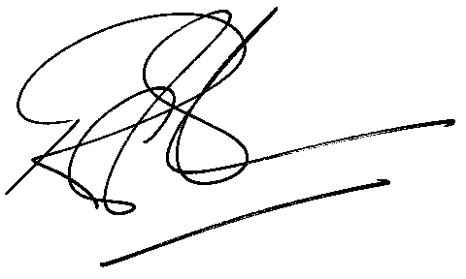

Rod Gravelet-Blondin
Senior General Manager
Commodity Derivatives Division
Tel : +27 11 520-7258
Fax : +27 11 520-7558
RodGB@jse.co.za

Distributed by the Company Secretariat +27 11 520 7591

