Market Notice

Number: | A1055
Date: | 26 May 2009

Introduction of the May 2010 expiries.

Please note the May 2010 expiry months for WMAZ, YMAZ, SUNS WEAT and SOYA contracts will be introduced for trading on Monday, 01 June 2009.

Where applicable, the storage rates, location differentials and grade discounts for the various products have not being finalized and will only be available closer to the new marketing season.

Participants are again reminded that the JSE trades the underlying grades of products as published by the National Department of Agriculture in South Africa, should any changes be made to these at any time they will applied to the applicable derivative contract(s).

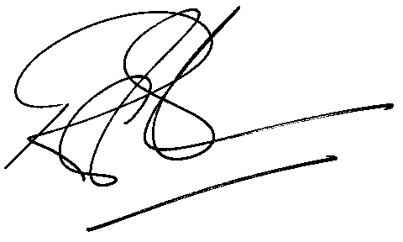

Rod Gravelet-Blondin
Designation | Senior General Manager
Division | Commodity Derivatives Division
Tel | +27 11 520-7258
Fax | +27 11 520-7558
E-mail address: | RodGB@jse.co.za

Distributed by the Company Secretariat +27 11 520 7591

