Market Notice

Number: | A1058
Date: | 1 June 2009

Amendment to the Sunflower Seed and Soya position limits

When the above contracts were introduced 10 years ago, it was agreed to apply position limits for the delivery month to reduce the potential for market distortions since there was a limited quantity of underlying physical crop available in South Africa. The contract specification for sunflower seed restricted physical deliveries to product of South African origin, whilst soya beans permitted beans from any origin to be delivered, provided that they meet the South African grading standards as defined by the Agricultural Products Standards Act.

The underlying crop production has increased over the years and there is now an increased need to re-assess the adequacy of the existing position limits. The current limits as they appear in the contract specifications are:

Sunflower Seeds - clause 7.2 C
No participant or associated group of participants may hold in excess of 1000 contracts of a particular delivery month within 10 days of the delivery month in question
Soya Beans - clause 9.2.C
No participant or associated group of participants may hold in excess of 800 contracts of a particular delivery month within 10 days of the delivery month in question

The above clauses will be amended in the contract specifications to ensure that the position limit reflects approximately 10% of the underlying South African crop. In addition, please also note that we have acknowledged the request for greater position limits during the harvest period.

Taking into account the above requirements, these revised limits are:-

Sunflower Seeds – AMENDED clause 7.2 C
No participant (defined as a member or client) or associated group of participants may hold in excess of 1700 contracts of a particular delivery month contract within 10 days of the first delivery day of the month in question, except during the harvest period from March up to and including May, the position limit will allow for a maximum of 2500 contracts.
The JSE will provide special dispensation to financiers in terms on the above position limits should they confirm in writing that their positions are a result of a funding transaction where the client is no longer able to repurchase the product.

Soya Beans – AMENDED clause 9.2.C
No participant (defined as a member or client) or associated group of participants may hold in excess of 1600 contracts of a particular delivery month contract within 10 days of the first delivery day of the month in question, except during the harvest period from March up to and including May, the position limit will allow for a maximum of 2400 contracts.
The JSE will provide special dispensation to financiers in terms on the above position limits should they confirm in writing that their positions are a result of a funding transaction where the client is no longer able to repurchase the product.

The position limits will be revised each year by the JSE and will be based off the South African crop as estimated by the Crop Estimates Committee during the month of January.

Members are advised to ensure that all of their clients who trade in or who have positions in either of these two products are both aware of and comply with these limits. The limits will take effect as from 17 June 2009 for the next delivery month - July09.

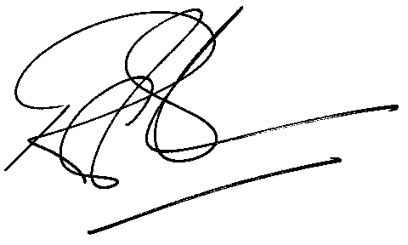

Rod Gravelet-Blondin
Designation | Senior General Manager
Division | Commodity Derivatives Division
Tel | +27 11 520 7258
Fax | +27 11 520 7558
E-mail address: | rodgb@jse.co.za

Distributed by the Company Secretariat +27 11 520 7591

