Commodity Derivatives Market Notice

Number: | A1064A
Date: | 8 June 2009

Introduction of Options on the Chicago Corn Futures Contract

The May2009 Chicago Corn contract settlement process was a success with all parties involved comfortable with the settlement methodology in place. The number of contracts traded continues to improve with just over 7600 traded thus far.

The JSE, after consulting various option writers, has agreed to enable options trading on the CORN contract as from the Dec09 expiry. The contract specification is attached however it is important to understand the expiration process that will be implemented. Since the final futures cash settlement value is calculated outside of the standard trading hours, the options will expire on the last trading day together with the futures contract, but the actual option expiration will only be processed the following business day once the final cash settlement value is known. An example of this process is included in the fact sheet provided. The options will be enabled on Friday, 12 June 2009 and will trade with full member disclosure. There is no need to trade anonymously as the approved market makers are not required to quote on options. The market will therefore be aware of option writers who are willing to participate in the contract.

The futures contract trading costs specific to the JSE, will be reduced to R15.00 per contract (incl VAT) as from Friday, 12 June 2009, this will be the same as the options trading cost. Members are encouraged to enquire with their Clearing Members to understand if this benefit will be passed on.

The Mar2010 and Jul2010 expiries will also be introduced for trading on Friday, 12 June 2009 with options enabled at the same time. The Mar2010 last trading day is on 25 February whilst Jul2010 last trading day is on 29 June.

Should you have any questions specific to the options contract please contact Chris Sturgess (+27 11 5207299) or Graham Voller (+27 11 5207176) or email commodities@jse.co.za

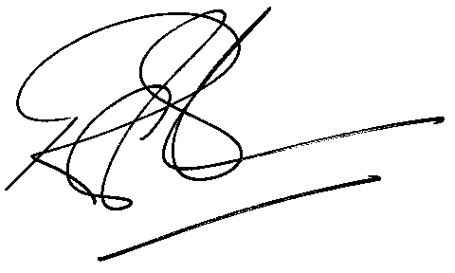

Rod Gravelet-Blondin
Designation | Senior General Manager
Division | Commodity Derivatives Division
Tel | +27 11 520 7258
Fax | +27 11 520 7558
E-mail address: | rodgb@jse.co.za

Distributed by the Company Secretariat +27 11 520 7591

