Commodity Derivatives Market Notice

Number: | A1066
Date: | 9 June 2009

Safex silo receipt reported lost

Please will members and clients note that the following NWK Limited (silo owner code NWK) Safex silo receipt has been reported lost by Standard Bank and therefore is canceled with immediate effect:
Safex receipt number: 131837
Original depositor: AW Wood
Tonnages: 50 ton
Product: Sunflower seeds
Location: Sannieshof

To further assist the market, the exchange will record on its webpage a list of all Safex silo receipts reported lost. The exchange does not guarantee the accuracy of the webpage since silo operators will be responsible for confirming the cancelation.
The information can be viewed via the following shortcut:
http://www.safex.co.za/ap/docs/receipts_lost/Safex%20Silo%20receipts%20reported%20lost.pdf

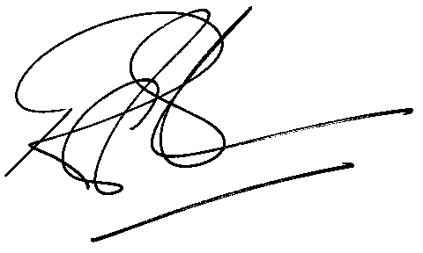

Rod Gravelet-Blondin
Designation | Senior General Manager
Division | Commodity Derivatives Division
Tel | +27 11 520 7258
Fax | +27 11 520 7558
E-mail address: | rodgb@jse.co.za

Distributed by the Company Secretariat +27 11 520 7591

