Commodity Derivatives Market Notice
Number: | A1071
Date: | 29 June 2009

Physical delivery at Migdol & Kameel silo’s

With additional silo operators utilizing the Electronic Silo Certificates (ESC) system, so the instance has arisen where more than one silo operator has the same name for a registered delivery point. In order to accommodate Suidwes Landbou as well as NWK on the ESC system, where Migdol and Kameel silo’s are no longer unique, we are required to differentiate between the various silo owners in the description of the silo location. The JSE systems together with ESC will as from Tuesday morning 30 June 2009, identify the silo location with the below abbreviation included in the name:
NWK Migdol
NWK Kameel
SWL Migdol
SWL Kameel

All existing valid silo receipts entered under NWK will be converted into the new format.

It is imperative that members take note of the above change and when giving notice of delivery via Nutron for the abovementioned silo’s , the abbreviation (full name as described above) must be captured under silo location in order for the silo receipt to be verified for delivery. Where no clash exists, the usual format should be captured for the silo location.

Should you encounter any technical issues please contact the commodities team on 011 520 7535 or email commodities@jse.co.za or ESC on 011 797 5591.

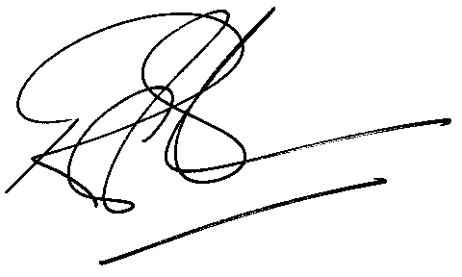
Rod Gravelet-Blondin
Designation | Senior General Manager
Division | Commodity Derivatives Division
Tel | +27 11 520 7258
Fax | +27 11 520 7558
E-mail address: | rodgb@jse.co.za

Distributed by the Company Secretariat +27 11 520 7591

