Commodity Derivatives Market Notice

Number: | A1073
Date: | 02 July 2009

Safex silo receipt reported missing

Please will members and clients note that the following Safex silo receipt has been canceled with immediate effect, it is assumed the receipt was never part of the original print run:

Safex receipt number: 138001

To further assist the market, the exchange will record on its webpage a list of all Safex silo receipts reported lost or missing, the JSE does not guarantee the accuracy of the webpage since silo operators will be responsible for confirming the cancelation.
The information can be viewed via the following shortcut:
http://www.safex.co.za/ap/docs/receipts_lost/Safex%20Silo%20receipts%20reported%20lost.pdf

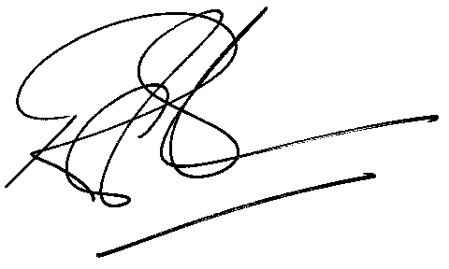

Rod Gravelet-Blondin
Designation | Senior General Manager
Division | Commodity Derivatives Division
Tel | +27 11 520 7258
Fax | +27 11 520 7558
E-mail address: | rodgb@jse.co.za

Distributed by the Company Secretariat +27 11 520 7591

