Market Notice

Number: | A1083
Date: | 29 July 2009

Safex silo receipt reported lost

Please will members and clients note that the following Suidwes landbou (silo owner code SWL) Safex silo receipt has been reported lost by Rand Merchant Bank and therefore is canceled with immediate effect:
Safex receipt number: 139640
Original depositor: FJS Jacobs
Tonnages: 100 ton
Product: Yellow maize
Location: Makwassie

To further assist the market, the exchange will record on its webpage a list of all Safex silo receipts reported lost. The exchange does not guarantee the accuracy of the webpage since silo operators will be responsible for confirming the cancelation and information first.
The information can be viewed via the following shortcut:
http://www.safex.co.za/ap/docs/receipts_lost/Safex%20Silo%20receipts%20reported%20lost.pdf

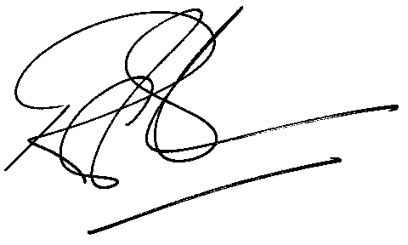

Rod Gravelet-Blondin
Designation | Senior General Manager
Division | Commodity Derivatives Division
Tel | +27 11 520 7258
Fax | +27 11 520 7558
E-mail address: | rodgb@jse.co.za

Distributed by the Company Secretariat +27 11 520 7591

