Market Notice

Number: | A1087
Date: | 7 August 2009

Mandatory NUTRON Front End Upgrade – 24 August 2009

Dear Derivatives Stakeholder

The JSE is continuously striving to enhance the trading software available to the market, therefore please take note that a NUTRON trading engine upgrade is scheduled for the 24th August 2009. This upgrade will provide several enhancements and bug fixes. Due to certain message changes it is a requirement that all trading terminals upgrade to the new version as the current version will no longer be operational as from Monday 24 August 2009.

See below for a summary of included fixes/enhancements – and details on whether these impact the Commodities, Equity Derivatives NUTRON Front End and/or the Derivatives API specification:

 |  |  | API users only
 | Enhancement \ fixes | Market | API impact | API re-conformance required / Message No.
1 | Added a separate window on NUTRON front end for Variance Swaps | EDM | NO | NO
2 | Rectified filtering problem on View Trades Screen | CDD / EDM | NO | NO
3 | Added Origin, Exchange Reference and Reference as fields that can be filtered | CDD / EDM | NO | NO
4 | On adding a new client field descriptions changed to Surname and Full Names (fields made mandatory for NUTRON front end when individual is selected) | CCD / EDM | NO | NO
5 | NUTRON front end futures window setup now saves after instruments order has been manually setup | CDD / EDM | NO | NO
6 | Phase 1; EFP confirmation added when doing a physical deliveries within the same member firm | CDD | YES | YES / 143
7 | Added new download for dividend payments | EDM | YES | NO
8 | Added member trading limits setup on a per instrument basis | CDD / EDM | YES | YES / 6
9 | Added ‘entered time’ and ‘allocation time’ to deals file download | CDD / EDM | YES | NO
10 | Day’s history graph sometimes shows starting value as 0 - resolved | CDD/ EDM | NO | NO
11 | Report only transactions where the price change is more than the initial margin from the previous day’s MTM will go into Unmatched with a status of B/S requiring a clearing member to accept them | EDM | YES | NO
12 | Add client multiplier to the Client file download | CDD / EDM | YES | NO
13 | Add functionality to allow a member to set a client margin multiplier factor | CDD / EDM | YES | YES / 150
14 | Change to only show positions on or before expiry of a contract (Settlement Margin affected positions post closeout will no longer reflect as 0 in the positions file download) | EDM | NO | NO
15 | Option volatility calculation to default to 200 when it cannot be calculated | CCD | NO | NO
16 | Added Dividend Paid field to Instrument Data and Daily Account Summary (Clearing Members only) downloads | EDM | YES | NO
17 | Added Instrument Short Name field to Dealer Risk Value Limit data download | CCD / EDM | YES | NO
18 | Add member or branch details to delivery and assignment report | CCD | NO | NI
19 | Naming convention for 2010 contracts incorrect for split contracts for API users. | CCD | YES | NO
20 | Users reported problems with their positions view not refreshing | CCD | NO | NO
21 | Corrected interpretation on the defaults in the “user config” window | CCD/EDM | NO | NO

The new NUTRON front end (Version 1.0.0.20966) is now available as a manual download from the following location:

http://www.safex.co.za/pub/August2009FrontEnd

Users may download the front end and use it for testing in the JSE’s test environment. This version of the NUTRON front end will only successfully login to the JSE’s production derivatives market from Friday 21 August 2009 after the Equity Derivatives end of day procedures are completed.

The click once installation sources will be available from Friday 21 August 2009 after 19h30.

Only version 1.0.0.20966 of the NUTRON front end will be able to connect to the Derivatives production systems from 24 August 2009.

API users please note that messages which require re-conformance will only be enabled for those applications which have successfully been re-conformed on the messages concerned.

Should you require any assistance upgrading your terminals on the Saturday, there will be support between 09h00 to 11h00 at the JSE, either email derivative_info@jse.co.za or contact +27 11 520 7777,

Please direct any further questions to derivative_info@jse.co.za

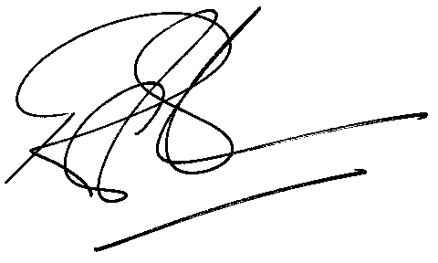

Rod Gravelet-Blondin
Designation | Senior General Manager
Division | Commodity Derivatives Division
Tel | +27 11 520 7258
Fax | +27 11 520 7558
E-mail address: | rodgb@jse.co.za

Distributed by the Company Secretariat +27 11 520 7346

