Commodity Derivatives Market Notice
Number: | A1088
Date: | 17 August 2009

Safex silo receipts reported lost

Please will members and clients note that the following Safex silo receipts has been reported lost by SASKO and therefore will be canceled with immediate effect:
Safex receipt n Original depositor Tonnages Product Location
136510 Senwes 200 Wheat B1 Raathslvei
136511 Senwes 100 Wheat B2 Tierfontein
136512 Senwes 50 Wheat B1 Wesselsbron
136513 NWK 300 Wheat B1 Delareyville
136514 OTK 50 Wheat B2 Kaallaagte
136515 Senwes 50 Wheat B1 Van Tonder
136516 Senwes 50 Wheat B1 Petrusburg
136517 Senwes 50 Wheat B1 De Brug
136518 Senwes 350 Wheat B2 Willemsrus
139391 Suidwes Landbou 50 Wheat B3 Christiana

To further assist the market, the exchange will record on its webpage a list of all Safex silo receipts reported lost. The exchange does not guarantee the accuracy of the webpage since silo operators will be responsible for confirming the cancelation and information first.
The information can be viewed via the following shortcut:
http://www.safex.co.za/ap/docs/receipts_lost/Safex%20Silo%20receipts%20reported%20lost.pdf
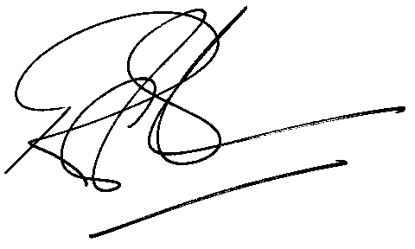
Rod Gravelet-Blondin
Designation | Senior General Manager
Division | Commodity Derivatives Division
Tel | +27 11 520 7258
Fax | +27 11 520 7558
E-mail address: | rodgb@jse.co.za
Distributed by the Company Secretariat +27 11 520 7591

