Market Notice

Number: | A1094
Date: | 21 August 2009

Request to register Amersfoort, Maizefield, Morgenzon and Marble Hall as JSE approved delivery points

As per notice A713, any request to register a new delivery point by a silo operator will first be distributed to the market for comment.

AFGRI Operations Limited (Reg no 1995/005872/06) has requested that the above silos be registered as a white and yellow maize, wheat and sunflower seeds delivery points. Please note these four silos will only have road access and so the suggested location differential is based on current road rates ONLY. The following details are specific to the silo complexes:

Situated on main Proposed differential for:
road route Capacity Maize Wheat Sunflower Seeds
Amersfoort N17 59 000 tons -R185/t -R185/t -R240/t
Morgenzon N17 54692 tons -R169/t -R169/t -R220/t
Maizefield N17 40769 tons -R160/t -R160/t -R208/t
Marble Hall N11 87 308 tons -R160/t -R160/t -R208/t

Please will members consult with their clients and lodge any objections to the above inclusions or comments regarding the proposed differential to Joey Oosthuizen on email joeyo@jse.co.za , these must be received no later than 11 September 2009.

The exchange will publish a final notice confirming its decision.

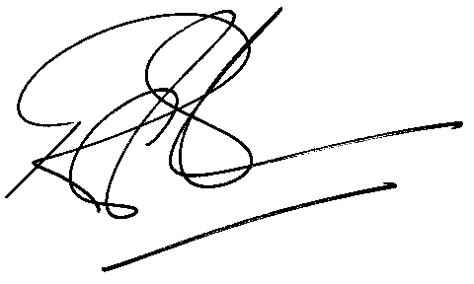
Rod Gravelet-Blondin
Designation | Senior General Manager
Division | Commodity Derivatives Division
Tel | +27 11 520 7258
Fax | +27 11 520 7558
E-mail address: | rodgb@jse.co.za

Distributed by the Company Secretariat +27 11 520 7591

