Market Notice

Number: | A1095A
Date: | 24 August 2009

Introduction of further Foreign Referenced Commodities – Crude Oil, Gold and Platinum

The JSE is delighted to extend its current licensing agreement with the CME Group to include the following commodities, namely crude oil, more specifically West Texas Intermediate, gold and platinum. These products will be cash settled off NYMEX and COMEX respectively in a similar fashion to the current Chicago Corn contract. The detailed contract specifications are included as separate attachments to this notice.

Although the Commodity Derivatives Division is aiming to introduce these products towards the end of September this year, it has decided to provide the contract specifications together with all the other trading details earlier to afford all interested members sufficient time to inform their clients of the new products.

The new products already have the approval of all Commodity Clearing Members with the final launch date dependant on the market makers – a notice will be distributed once the launch date is confirmed with the intention to introduce all products at the same time.

The JSE has again worked closely with the market makers who will ensure they are able to provide pricing in South African Rands on the products introduced. The institutions, including key contact person, who have confirmed their commitment and who are currently preparing for the new products are:
ABSA – Byron Woods
Nedbank – Douw Steyn
Rand Merchant Bank – Bevan Jones
Standard Bank – Hardi Wilkins

The web page www.safex.co.za/ap under the “Products” banner is updated with details on expiry dates, cash settlement process, contact details for each of the market makers together with a detailed brochure describing how foreign referenced commodities are available for trade and risk management by the exchange. This will serve as a useful reference guide for clients interested in trading the products.

The current commodity trading hours will also be adjusted when these new products are launched, for details on the exact process a separate notice will be distributed, please see notice A!!!!! . Note that the three hour trading session for the current grain products will remain unchanged including the processing of all physical deliveries. The major impact will be that the end of day run will only commence after 16h00 each day.

Although the products will be launch on the Commodity Derivatives Market of the JSE, there is currently a work stream underway which has the JSE Executive and all Clearing Members support, to be able to offer the Equity Derivative Members access to the same cash settled product set, namely crude oil, gold and platinum. These products will be made available through a common trading window accessed by both markets and ultimately cleared and risk managed each day by their respective Clearing Member. In other words trades specific to Commodity Derivative Members will be cleared with the 16h00 end of day run whilst Equity Derivative Members trades will be cleared through their 18h00 end of day run. All trading statistics, for example high, low, volume and open interest will be reported based on the common trading activity. It is envisaged this facility will be ready late February 2010. Should there be any specific questions regarding this new initiative please contact Chris Sturgess on +27 11 5207299 or email Chriss@jse.co.za.

The Commodity Derivatives Division through its central email address commodities@jse.co.za is happy to answer any queries regarding the new products and once the official introduction date is confirmed will be hosting various information sessions together with the market makers to discuss the products in more detail.

We remained committed to providing price risk management instruments for the commodities market in South Africa and look forward to the new opportunities the additional products bring.

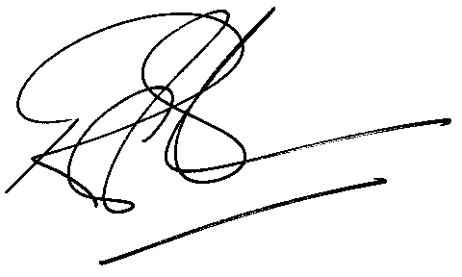

Rod Gravelet-Blondin
Designation | Senior General Manager
Division | Commodity Derivatives Division
Tel | +27 11 520 7258
Fax | +27 11 520 7558
E-mail address: | rodgb@jse.co.za

Distributed by the Company Secretariat +27 11 520 7478

