Market Notice

Number: | A1100
Date: | 26 August 2009

Wheat Location Differentials 2009/2010

Notices A1092A & B and A1098 & B have reference.

Please be advised that unfortunately it seems as if a gremlin crept into the complicated spreadsheet determining the differentials as distributed. We are currently ensuring that all the differentials are in fact correct and will revert with the final list in due course. We apologize for this complication. The new differentials will not be posted on the website until the calculations have been finalized. The reasoning for the change in differentials remains as detailed in the notices distributed and broadly speaking the differentials are correct, but please take note that they are subject to final ratification.

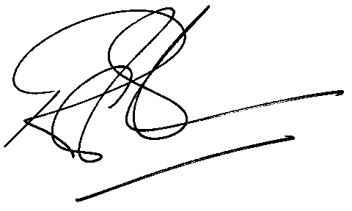

Rod Gravelet-Blondin
Designation | Senior General Manager
Division | Commodity Derivatives Division
Tel | +27 11 520 7258
Fax | +27 11 520 7558
E-mail address: | rodgb@jse.co.za

Distributed by the Company Secretariat +27 11 520 7591

