Market Notice

Number: | A1110
Date: | 22 September 2009

Introduction of a non-tradable Rand Dollar exchange rate contract to reference the Chicago Corn contract expiries

The Chicago Corn contract, introduced earlier in the year, is traded in South African Rand with the contract ultimately cash settled off the Chicago Board of Trade (CBOT). Since its introduction, there have been a number of requests to assist in adding further transparency around the currency component as the South African derived corn price is a function of the CBOT price, a Rand Dollar spot price and then the forward points to a specific expiry.

The JSE in partnership with Standard Bank of South Africa will, on a trial basis, assist the market by providing a non-tradable bid and offer quote on the Rand Dollar exchange rate specific to each corn expiry. The JSE will make use of its current auctioning functionality to display the quotes by Standard Bank during normal trading hours. Since both a bid and offer will be quoted, clients will be able to reference this in order to benchmark the current Chicago Corn double quoted in Rand.

Should clients be interested in trading the quoted currency they can contract Standard Bank directly:
Contact person: Hardi Wilkins
Telephone: 011 378 8612
Email: hardi.wilkins@standardbank.co.za

The new contracts will not form part of the default group of contracts available on Nutron and so for those interested in viewing the quotes these must be added separately. To do this please add them via the front end by right clicking on the main futures window, select the “add/delete contracts” followed by “add/delete class of contract”

Select the new contract code RDCC (Rand Dollar Chicago Corn quoting) and select the “add” button followed by OK
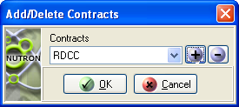
The various pre-loaded expiries will then form part of the main futures window with the South African Rand quoted per US Dollar
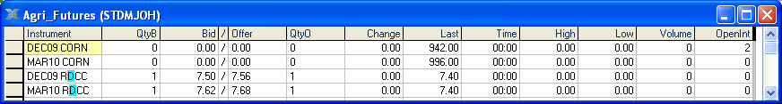

Please remember these quotes will not be tradable on NUTRON however should members wish to trade the currency component they should contact Standard Bank. The functionality is not exclusive to Standard Bank with other authorized dealers welcome to participate, for this reason the quoting will not be anonymous and members will be able to view those Reserve Bank Authorised Dealers participating in the quoting. The listed expiries will mirror those of the Chicago Corn contract.

The Dec09, Mar10 and Jul10 expiries will be introduced on Wednesday 23 September 2009 for a trial period. We trust the currency quoting will add further transparency to those clients interested in viewing the all in (spot plus fwd points) Rand Dollar exchange rate specific to each corn expiry. Members are welcome to provide comments regarding the service, please email commodities@jse.co.za .
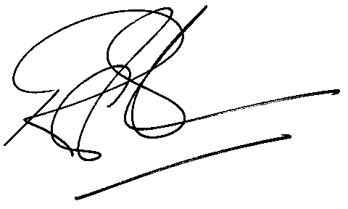
Rod Gravelet-Blondin
Designation | Senior General Manager
Division | Commodity Derivatives Division
Tel | +27 11 520 7258
Fax | +27 11 520 7558
E-mail address: | rodgb@jse.co.za

Distributed by the Company Secretariat +27 11 520 7591

