CONFIDENTIAL

Yield-X Nutron Front End Training Guide -
New and enhanced features.



Version 1.0
September2009

Produced by: JSE
Reviewed by: JSE
Version: Version 1.0
Date: September 2009

This document is confidential and contains property belonging to the JSE Limited (the JSE). Neither this document nor its contents may be disclosed to a third party, nor may it be copied, without the JSE’s prior written consent.
CONFIDENTIAL

Table of Contents
1. Overview 2
1.1 Purpose of this document. 2
1.2 Intended Audience 2
2. Downloading the Front End 2
3. New Features 4

Overview

Purpose of this document.

The purpose of this document is to highlight new and improved features on the Nutron Yield-X trading front end as compared to the current Yield-X Trading Front End.

Intended Audience

All traders and users of the current Yield-X Trading Front End.

Downloading the Front End

The latest version of the Nutron Yield-X front end is available to all stakeholders to download at the following link http://10.6.224.11/.

Stakeholders may contact the JSE on yield-x_info@jse.co.za for information on how to install the latest version of the NUTRON Yield-X front end for testing purposes. For manual downloads use:
http://www.safex.co.za/pub/YieldX_Replacement_FrontEnd/ or use Click Once on:
http://10.6.224.30:4469

- Open the above link

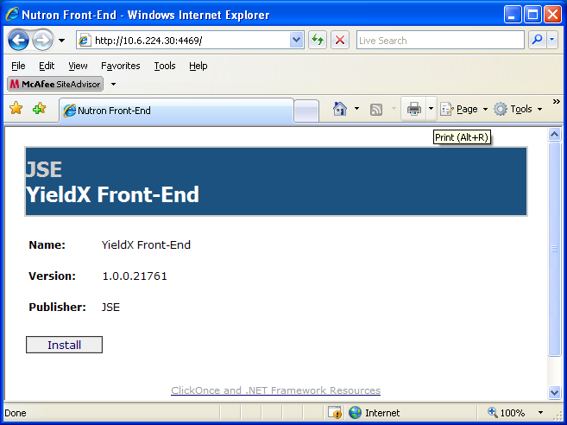

Press install on your web browser to launch the application install below

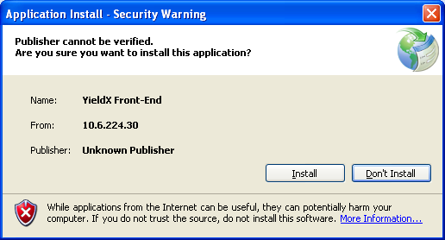

Press install

New Features

- Add Default Windows: Now the trading windows as well as the views for a set market are automatically added when selecting to ‘Add Default windows’.

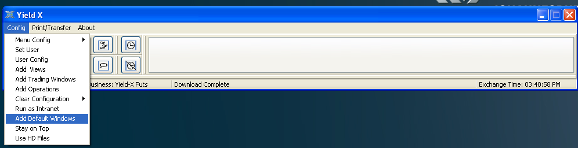

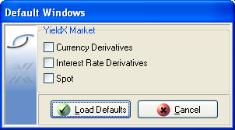

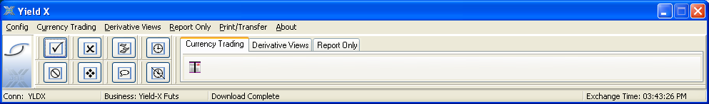

- Asset Class Futures: Allows customisation of a trading screen where the user has the ability to select which Contracts they would like to view and trade.

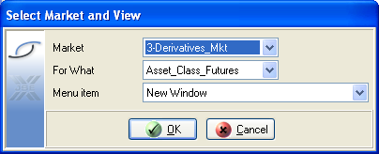

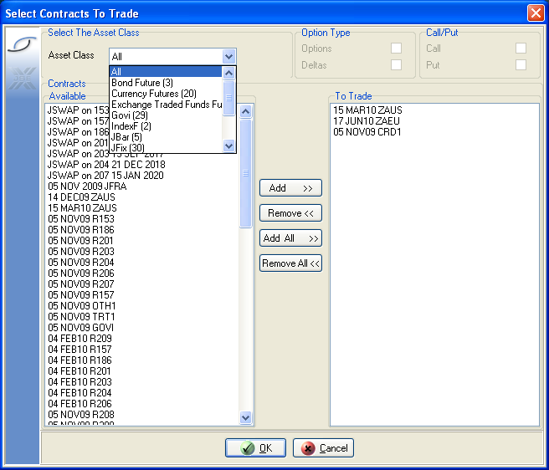

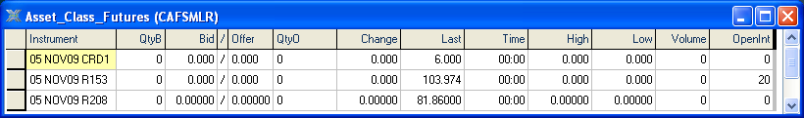

- Central options window: Allows customisation of a trading screen where the user has the ability to select which Option Contracts they would like to view and trade. This function works in the same manner as the Asset Class Future screen.

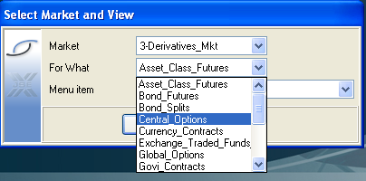

- There is a new Option DDE Trader, allowing the DDE functionality to be incorporated into option trading as well.

- Position Views are now broken down into more extensive views:
- Positions View: This view shows the positions broken down into dealer level. This includes Dealers, Clients and Sub Accounts.

- Con Positions View: This view shows the positions on a principal level. This includes Members, Clients and Sub Accounts.

- Consolidated Member Positions View: This view shows the positions on a member level. This includes Members and Clients

- Deal management has been given more functionality on the front end this includes:
- Rolling Forward of positions. You need to have a potion in the near contract to use this function.

- Roll over functionality. You do not need a position in the near contract to use this function.

- Div Bulk, this gives the user the ability to div a trade out to more than one client or sub account at a time. To use the function, user needs to first setup a portfolio.

Open the view trades window → select “Portfolio”

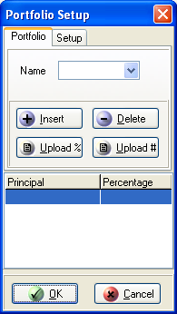

Two options are available to setup a portfolio, either manually or by using a pre formatted spreadsheet. This spreadsheet can be requested from the JSE.

- Trade Correct is a new functionality added to counter incorrect Divs.
Open the “View trades screen, and select the Trade Correct button
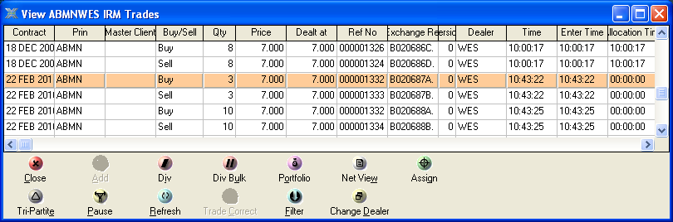

Select a new principal.

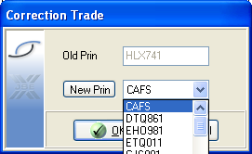

- Change dealer functionality allows users to select multiple trades and to change the dealer and/or sub account on these trades.
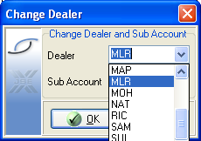

- The new Front End has more functionality with regards to setting up User Configuration. To access user configuration select → Config → User Config → Yield-X.

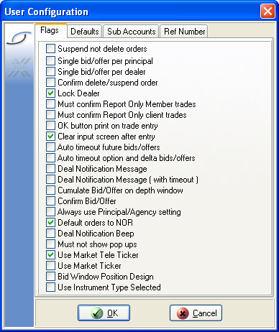

- Examples of new features in user configuration include:

- Confirming Bids/Offers, this allows fewer places for mistaken orders being put up on screen.
- Deal Notification Beep, this gives the user an idea when one of their orders have been hit and resulted in a deal.
- Use Market Ticker/Market Tele ticker, this gives the user the choice to switch between the Market ticker which opens up a whole new window and the Tele Ticker which opens as a docked screen on the front end.
- Use Instrument type Selected: By ticking this, this allows the user to only see instruments selected in the Instrument Type Tab
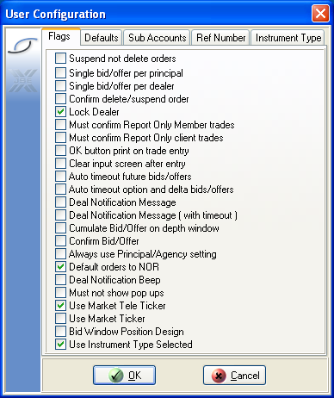

This will create a new tab on the top right corner of the user config view.

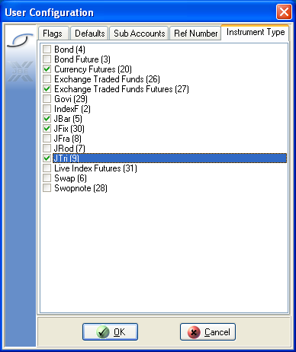

By selecting the different instrument types in this screen – the dealer/user will only see deals/positions in the selected instrument type only

- The user is now given the functionality to create, validate and restrict clients via the front.

- The user is now given more accessibility with regards to setting up trading limits.

Select Config → Add Operations → Yield-X Configure Access

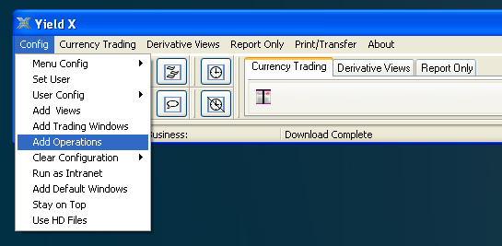
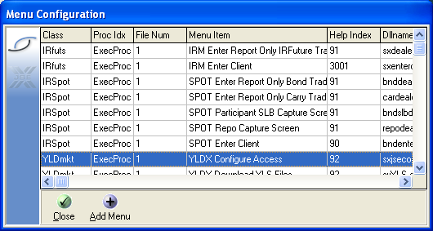

- Clearing members are now able to set limits for their respective members via the front end.

- Master Dealers are now able to set limits for themselves as well as other dealers for their member via the front end.
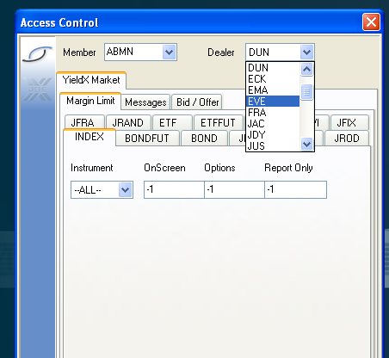
Select dealer code
Select contract / instrument
Set the limits.

- Dealers are now able to set their own limits via the front end in the same manner as above.

- Print Transfer also allows for a lot more functionality with regards to different file downloads as well as a new functionality to select a specified date for the print/transfer.
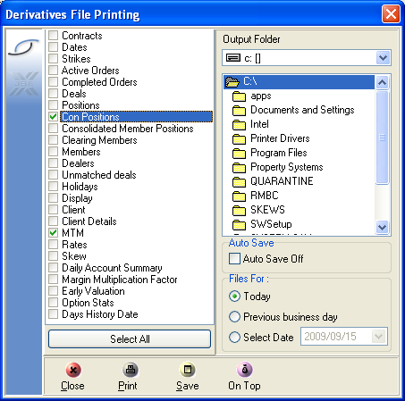

- Additional filters have been added to all view screens as well as the Report Only Trade Screen.

- Users have ability to filter their entire front end to only show transactions completed on particular instrument types.

- Real time open interest is displayed on the trading window.





