Market Notice

Number: | A1118
Date: | 08 October 2009

Initial margin requirements for the new commodity products including an introductory JSE fee waiver for all trades

Crude oil, gold and platinum futures contracts will be introduced for trading tomorrow morning the 9th October 2009. A new milestone for the Commodity Derivatives Market which for the first time since inception will provide instruments that will trade, including the admin period, up until 16h00. This is also the first set of products outside of the soft commodity range thereby further enhancing South Africa’s commodity derivative products. To celebrate this occasion the JSE has decided that it will refund all participants their JSE trading fee component for crude oil, gold and platinum for transactions up to and including Friday 23rd October 2009. This will be processed through a single reimbursement at the end of the period to Members via the Clearing Member. Clearing Members reserve their rights to bill as per their fee schedules.

The initial margin requirements for the products have been finalized as follows, please note these will be revised monthly unless market conditions require otherwise:

Contract Code | Expiry Date | Initial Margin Requirement  per contract | Spread Margin Requirement
Crude Oil (WTIO) | Dec2009 | R 5700.00 | R 1700.00
Crude Oil (WTIO) Gold (GOLD) | Feb2010  Dec2009 | R 5800.00  R 4300.00 | R 1700.00  R 1300.00
Gold (GOLD)  Platinum (PLAT)  Platinum (PLAT) | Apr2010  Jan2010  Apr2010 | R 4400.00  R 7600.00  R 7800.00 | R 1300.00  R 2300.00  R 2300.00
The JSE is considering providing class spread offset between Gold and Platinum and is currently analyzing the necessary reference trading data from the international markets.

For more information about the products please refer to the “products” tab on the following web page www.safex.co.za/ap. Please note that the crude oil settlement process has been slightly amended to align the close out times with the currency component. The new process to determine the NYMEX close will be as follows:
The NYMEX settlement value will refer to an average of 15 iterations referencing trades in the underlying
derivative contract, taken every 1 minute for a period of 15 minutes ending 10h00 New York time (SA
Summer: 16h46 – 17h00 and SA Winter: 15h46 – 16h00) on the penultimate trading day of the NYMEX delivery month.

Should there be any further questions please contact the Division or email commodities@jse.co.za.

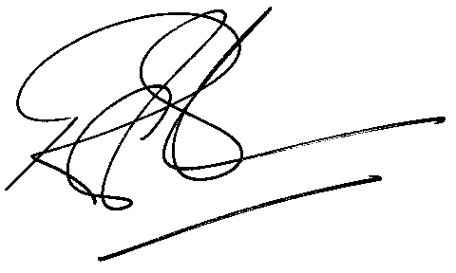

Rod Gravelet-Blondin
Designation | Senior General Manager
Division | Commodity Derivatives Division
Tel | +27 11 520 7258
Fax | +27 11 520 7558
E-mail address: | rodgb@jse.co.za

Distributed by the Company Secretariat +27 11 520 7591

