Market Notice

Number: | A1126
Date: | 21 October 2009

Registration of Amersfoort, Maizefield, Morgenzon and Marble Hall as JSE approved delivery points

Further to notice A1094 the JSE can confirm the below delivery points will be registered delivery points as from 2 November 2009.

AFGRI Operations Limited (Reg no 1995/005872/06) will issue SAFEX silo receipts on request for the following products, white and yellow maize, wheat and sunflower seeds for the below delivery points. Please note these four silos will only have road access.
Situated on main Differential for:
road route Capacity Maize Wheat Sunflower Seeds
Amersfoort N17 59 000 tons -R185/t -R192/t -R240/t
Morgenzon N17 54692 tons -R169/t -R176/t -R220/t
Maizefield N17 40769 tons -R160/t -R166/t -R208/t
Marble Hall N11 87 308 tons -R162/t -R168/t -R208/t

The maize differentials are applicable until 30 April 2010, the wheat rates are applicable until 30 September 2010 whilst sunflower seeds are applicable until 31 January 2010.
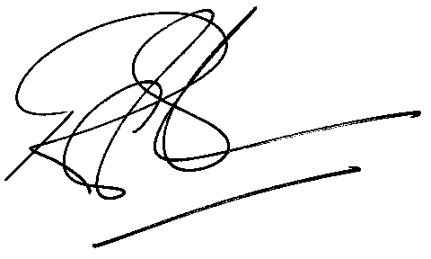

Rod Gravelet-Blondin
Designation | Senior General Manager
Division | Commodity Derivatives Division
Tel | +27 11 520 7258
Fax | +27 11 520 7558
E-mail address: | rodgb@jse.co.za

Distributed by the Company Secretariat +27 11 520 7591

