Market Notice

Number: | A1146A
Date: | 25 November 2009

The JSE to provide a FIX Interface
The JSE has embarked on an initiative to provide a FIX interface, in addition to the existing proprietary NUTRON API, that will allow JSE customers to submit and receive FIX messages directly onto the exchange without the need to first translate these messages to the proprietary API format.
In order to assist us in our investigation and to ensure that the development of a FIX interface meets the requirements and expectations of the JSE members and sponsors we would appreciate your time in completing the attached survey. Please forward this mail on to your technical representative for completion.
Please complete the attached survey and send, by close of business on the 6 December 2009 to markp@jse.co.za
Should you have any queries please contact Mark Pond on (011) 520-7312
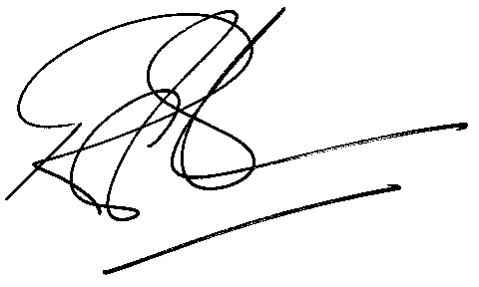
Rod Gravelet-Blondin
Designation | Senior General Manager
Division | Commodity Derivatives Division
Tel | +27 11 520-7258
Fax | +27 11 520-7558
E-mail address: | RodGB@jse.co.za

Distributed by the Company Secretariat +27 11 520 7591

