Market Notice

Number: | A1153
Date: | 2 December 2009

Voluntary deregistration of delivery points owned by Senwes

Further to notice A1133 – no objections were received regards the request by Senwes Limited to deregister the following delivery points:

For sunflower seeds:
- Jan Kempdorp
- Hartswater
- Magogong

For wheat, white maize and yellow maize:
- Hoogte silo

The JSE will therefore deregister with immediate effect the above silos for the applicable products.

.
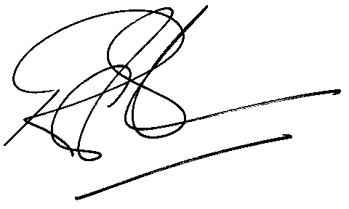

Rod Gravelet-Blondin
Designation | Senior General Manager
Division | Commodity Derivatives Division
Tel | +27 11 520 7258
Fax | +27 11 520 7558
E-mail address: | rodgb@jse.co.za

Distributed by the Company Secretariat +27 11 520 7591

