Market Notice

Number: | A1159
Date: | 10 December 2009

Consultation period extended in terms of investigating the introduction of a physically settled sweet sorghum contract

Further to notice A1132 distributed on the 2 November 2009, the JSE has received replies from participants who have expressed their keen support whilst others have noted their concern particularly due to the limited production and advised that trading derivatives on sorghum could impact the current supply and demand balance.

Please find below the trend of deliveries as published by SAGIS of sorghum vs. soybeans since 2000:

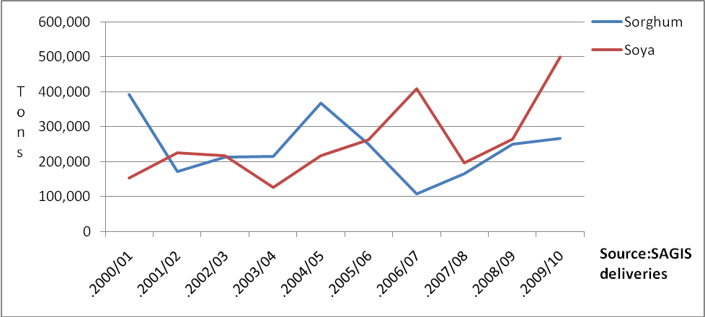

It is evident that in the early to mid 2000’s sorghum production outweighed soya. In April 2002 the SAFEX soya futures contract recorded its first trades. It can be argued that although the physical soya crop was limited, the instrument did provide a price risk management alternative. For the first two years of the soya contract, futures volumes remained minimal however since then the number of contracts traded continue to grow each year. Worthwhile noting that in 2006 when production was reduced to just over 120 000 tons, the exchange traded over 1 000 000 tons through the standardized 25ton contract (this includes futures and options contracts).

The feedback received from producers has recommended we do not proceed cautioning that the sorghum industry is too small and specialized for a derivatives market. They have also requested additional time to consult on a wider basis.

Those in favour of the contract have been traders (registered commodity members) and financing institutions who believe that by providing derivative instruments, financing to both buyers and sellers would be simplified and access made easier. They also believe by having access to derivative instruments the number of marketing alternatives would increase for producers.

Thus far silo owners have also offered the following delivery points should we wish to proceed with a deliverable contract:
VKB – Villiers, Ascent and Vrede :
Afgri –Leslie, Platrand, Standerton, Stoffberg, Bloekomspruit,Glenroy, Greylingstad, Harvard, Holmdene: Senwes – Vredefort, Weiveld and Gottenburg

The feedback received by those in favour of listing a sorghum futures contract are comfortable to trade a number of delivery points at the same basis price, therefore have no location differentials applicable. There has not been consensus around a possible contract size with 25ton, 50ton and 100ton contracts suggested.

The JSE, before making its final decision whether to proceed or not with the listing, would prefer market participants on both the buy AND sell side provide their input regards the suggested contract. The JSE therefore extends its consultation period to the 5th February 2010. Please confirm your support whether the JSE should proceed with the contract to Chris Sturgess on 011 5207299 or email chriss@jse.co.za.

We value your interest and feedback, either positive or negative, regarding the possibilities of a sweet sorghum futures and options contract for the South African market.

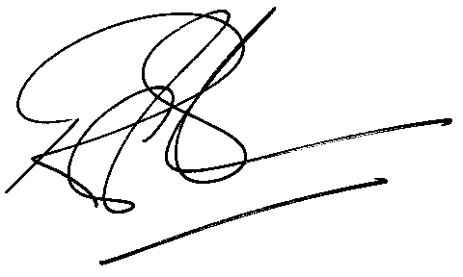

Rod Gravelet-Blondin
Designation | Senior General Manager
Division | Commodity Derivatives Division
Tel | +27 11 520 7258
Fax | +27 11 520 7558
E-mail address: | rodgb@jse.co.za

Distributed by the Company Secretariat +27 11 520 7591

