Silo Owner Notice

Number: | A
Date: | November 2009

Introduction of a physically delivered sorghum contract

Dear Silo Owner,

Since the production of sorghum in South Africa has increased over the recent years, there has been a request for the JSE to introduce futures and options on sorghum. This will assist all participants in the market with a transparent pricing mechanism whilst those trading the product through the exchange will be assured the necessary guarantees and price risk management instruments.

In order to be able physically settle the futures contracts, the JSE requires registered delivery points whereby authorised silo owners will issue SAFEX silo receipts that can be tendered for delivery in completion of a futures contract. For this reason we encourage all interested silo owners to complete the attached application form to ensure your delivery points are registered and able to participate in the contract.

Attached are the proposed contract specifications for the futures and options contract, of importance is that we will require silo owners to issue and honour all SAFEX silo receipts issued in terms of:
- Quality: Sorghum of grade GM1
- Quantity: once finalized all silo receipts will be issued in increments of the standardized contract size, either multiples of 25 tons or 100tons
- Origin: confirmation of the origin of the sorghum
- Storage date: please confirm the daily storage rate currently applicable and if you are comfortable we use the same methodology going forward to determine the increase, namely we reference the PPI figures two months prior to the market season
- The marketing season for sorghum will be XXXX

Should you be interested in registering delivery points for sorghum, please complete the attached application form and include the necessary supporting documentation.

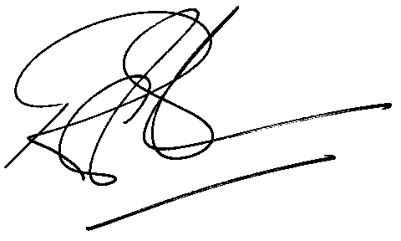

Rod Gravelet-Blondin
Designation | Senior General Manager
Division | Commodity Derivatives Division
Tel | +27 11 520 7258
Fax | +27 11 520 7558
E-mail address: | rodgb@jse.co.za

Distributed by the Company Secretariat +27 11 520 7591

